# Competitors Instructions Durham Small Boats Head 2023 – Updated 10/11/23

This race will be held under the British Rowing Rules of Racing, Guide to Safe Practice in Rowing, Local Rules, information published on the competition poster, marshals’ instructions and any other instructions issued by the Race Committee. Please read these Competitors Instructions carefully. Any serious transgression of these Instructions may result in disqualification by the Race Committee.

**SAFETY**

It is the competing clubs’ responsibility to ensure that all of their crews, scullers, coaches and those charged with the welfare of those racing have read and understood the following instructions. Captains and coaches must ensure that only competent crews have been entered and that their crews are properly prepared for the race. All coxes must be sufficiently competent and inexperienced crews should have experienced coxes.

Captains should ensure that their crews follow the standards for safety set out in the British Rowing Guide to Good Practice in Rowing and that all equipment is safe and secure, in particular bow balls and heel restraints. All coxes must wear a PFD (personal flotation device) on top of other garments, as must any competitor who cannot demonstrate the ability to meet the swimming standard or if they suffer from any medical condition, which means they could become unconscious or immobile. All boats must display a British rowing registration number.

Coxes, crews and scullers should all be suitably dressed for the weather conditions; it can be very cold and boats could be on the water for up to two hours. ***Hypothermia is a real danger*** so hats, gloves and other warm clothing are essential. Any competitor without sufficient kit or safety equipment will be returned to the nearest landing stage and may be disqualified as per the British Rowing Rules of Racing.

*The Committee does not accept any liability for crews or their equipment.*

**ACCESS AND PARKING**

Most crews will be boating from Durham ARC and boating times (for all boats) will be published on the final draw.

**Trailers**

Trailers should be taken down Green Lane and parked in the car park indicated on the boating instructions unless otherwise directed. There should be no towing vehicles or cars in the car parks as all the space is required for trailers and rigging boats.

**Cars**

All cars should be parked on the unmade-up road adjacent to Green Lane. **Please note the University Parking Regulations do not apply on Race days so you may ignore the signs.** There is further parking beyond the boat house, through the gate on the grass but please do not park close to the finish line as the finish officials need a clear view down the river at all times.

**BANDING**

Banding has been applied to some events based on the following ranking points ranges:

|  |  |  |  |  |  |  |
| --- | --- | --- | --- | --- | --- | --- |
|  | Band 1 | Band 2 | Band 3 | Band 4 |  |  |
| Op 4+ | 543+ | 269-414 | 116-125 | 0-86 |  |  |
| W 4+ | 330+ | 170-198 | 0-69 |  |  |  |
| Op J18 1X | 106+ | 0-70 |  |  |  |  |
| WJ16 1x | 144+ | 0-97 |  |  |  |  |
| WJ15 1x | 162+ | 0-32 |  |  |  |  |
| WJ15 2x | 202+ | 0-94 |  |  |  |  |
|  |  |  |  |  |  |  |
|  |  |  |  |  |  |  |
|  |  |  |  |  |  |  |
|  |  |  |  |  |  |  |

**REGISTRATION, WEIGHING IN AND RACE NUMBERS**

Race Control will be in the club office, on your right as your enter the club house. Please collect your race number from here. There will be both plastic numbers for the boat as well as a paper number for bow’s racing kit.

***REMEMBER if your number is not visible you will not be timed.***

Please return the plastic numbers at the end of the race.

Any crew substitutions or scratchings should be notified to Race Control as early in the day as possible. This is an important safety requirement.

**All coxes should be weighed in at control**. Coxes need to supply their own deadweight where applicable. Coxes boating from below Prebends can weigh in at Durham School Boathouse.

Race control will be open from 7.30am

**BOATING**

Please ensure you comply with the published boating times. These times will be enforced for ALL boats, not just those boating at DARC. This is so all boats arrive at the marshalling area in the correct order, making marshalling easier. Make sure your blades are beside (not on) the steps so you can reach them quickly once your boat is on the water. Boat with the bows upstream. Marshals will be on the landing stage to help you to boat quickly and safely; please listen to their instructions. Move off the landing stage to make any final adjustments to allow the next crew to boat as quickly as possible. There will be random checks of race licences, boats and equipment. It is the competitor’s responsibility to ensure they comply.

**GETTING TO THE START**

The start is approximately 2,000m downstream from the boathouse. Once you have left the landing stage turn when it is safe to do so. You should proceed down the river close to the starboard (bow) (Pelaw Wood) bank in single file. Please take care of shallow water on the DARC clubhouse side of the river between DARC and the bandstand. You may overtake a slower crew, assuming that the river is clear, but then move back in. There may be crews coming up the river or joining from other landing stages so do not assume it will be clear. After passing under Baths Bridge and New Elvet Road Bridge you need to go through Arch 2 of Elvet Bridge then proceed down to the marshalling area. On your way downstream, check the position of the Prince Bishop river cruiser as this may affect the racing line on exiting Elvet Bridge during the race. Take care as you approach Elvet Bridge on your way downstream, as there are some recently cleared logs on the landing and some larger or longer ones are still partially in the water adjacent to the landing. A normal approach to pass through the centre of Arch 2 should mean that you are clear of this hazard.

On your way downstream, take note of any potential obstacles that may need to be avoided while racing.

**MARSHALLING**

Please take time to look at the Marshalling Plan so you know roughly where you will be, which side of the river you will be marshalling on and which way the boat should be pointing. A strong stream is anticipated so crews should approach their marshalling position by proceeding downstream as normal, then turning to cross the river to marshal with bows upstream. This will make it easier for crews to maintain their position or to adjust to allow other crews to slot in. Always listen to the marshals and obey their instructions. Know your boat number and leave space for missing crews to slot in if you arrive before them. Keep your kit on until you are turned and ready to race. As you approach the start, be aware that crews will started with a 30 second gap to allow for safe racing.

**DURING THE RACE**

***During the race, you should be prepared to stop and give assistance to any crew or competitor that is in danger and bring to the attention of umpire, marshal, launch crew or other officials any incident occurring.***

In the race, crews being overtaken must move over to give the faster boat the best racing line: as a general guide, on the bends, the slower crew should move to the outside of the bend and on the straights they should move to the middle of the river. Marshals may impose time penalties on slower crews for failing to clear the racing line. The overtaking crew are responsible for maintaining a safe line whilst overtaking. All crews have a responsibility to avoid a collision and may be penalised if judged to have caused or contributed to a collision. Crews in bow-coxed boats must make their cox aware of any overtaking crew.

Crews should pass through Arch 1 of Elvet Bridge (the widest and with the best line) unless instructed to pass through Arch 2 (need to steer hard as you come out of this arch) by an official. ***DO NOT use either of the other arches: TIME PENALTIES will be awarded to any crew using these arches as they are not safe.*** Avoid exiting Arch 1 on too tight a course as there is an overhanging willow between the course and the bank which has been dragged downwards towards the river by recent high water.

**FINISH**

At the finish do not stop but keep paddling light to clear the finish area for the following crews. Please take care of shallow water on the DARC clubhouse side of the river between DARC and the bandstand. Continue upstream to disembark once there is space on the landing stage or, for crews who need to go down the course to another boat house, proceed upstream to turn around the buoy, then wait on the starboard (bow) side bank until the last boat has finished and you are told you can proceed down the course. No crew should move downstream of DARC until they are given permission. As the stream is expected to be fast on the outside of the bend, marshalling with bows upstream will make it easier to hold position.

**SHALLOW AREA**

Please note that there are shallows on the starboard side of the river from the Finish up to DARC landing stages. Please keep to the centre of the river to avoid damage to boats.

**TIME PENALTIES & DISQUALIFICATION**

Please ensure that you boat on time. Marshals on the landing stages will award time penalties or even turn crews away if they are late.

A 10 second penalty will be imposed for:

Being 10 minutes late to boat

Failure to be at your marshalling station 5 minutes before the advertised race start time

A 20 second penalty will be imposed for:

Being 20 minutes late to boat

Impeding other racing crew/s

Unsportsmanlike behaviour

Failure to follow a race official’s instructions

Taking the incorrect arch through Elvet Bridge

***In extreme cases you may be disqualified.***

**CYCLING**

Durham ARC remind competitors, spectators and officials that cycling is not permitted between Brown’s Boathouse (‘The Boat Club’) and Count’s House and that public access along the riverbank has NOT been closed for this competition. Cycling on the bank above Brown’s Boathouse can only be on the Pelaw Wood side cycle path. Durham ARC Regatta Committee accept no liability for any competitors, spectators or members of the public injured as a result of cycling.

**REFRESHMENTS**

Refreshments will be available throughout the day at DARC boathouse, please order at the 1860 Café counter.

**TOILETS AND SHOWERS**

These are available in DARC boathouse.

**RESULTS AND PRIZE GIVING**

The results of each division will be made available as soon as possible after each division. They will be posted in the boathouse and put on-line. Prizes will be awarded as soon as possible after the end of the final division. There will be no prize giving, prizes can be collected from the office.

Figure 1: River Wear Plan

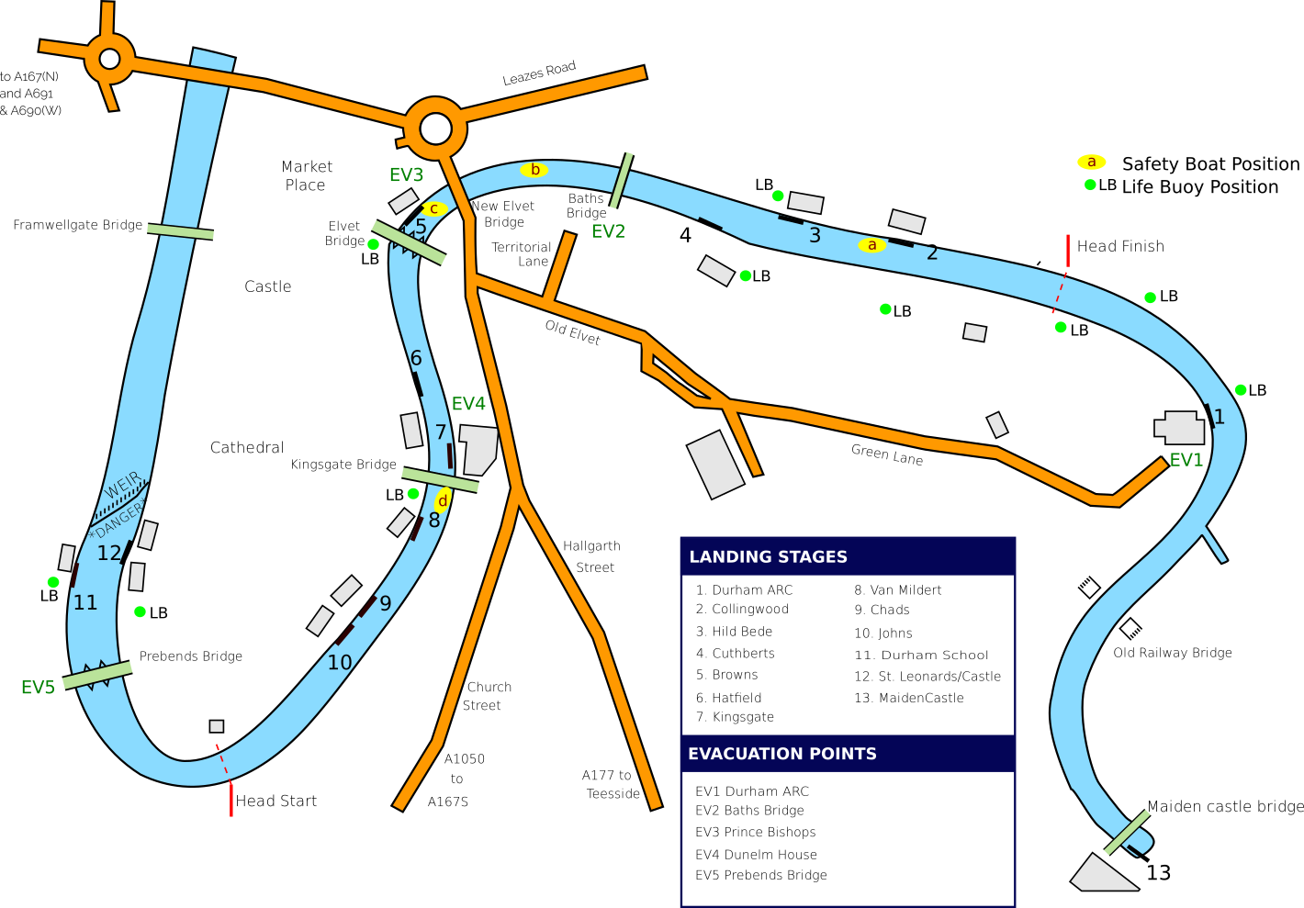

Figure 1: Map of the Wear

Umpires located at:

* Dunelm House landing stage
* Elvet Bridge (towpath downstream)
* New Elvet Bridge
* Baths Bridge
* Start & Finish

Marshals located at:

* UCBC/ St Leonard’s Boathouse
* Durham School
* Before counts house
* Downstream of St John’s BC Boathouse
* Above Finish
* Durham ARC landing stage

Figure 2: Marshalling Plan

Danger - Weir

Kingsgate Bridge

First Group marshals below Prebends bridge pointing upstream, when called this group will lead the division by moving upstream through the centre arch towards the start.

Fifth Group

First Group

Prebends Bridge

Counts House

[](https://www.google.co.uk/url?sa=i&rct=j&q=&esrc=s&source=images&cd=&cad=rja&uact=8&ved=0ahUKEwjmkMKA8MfKAhVLtBoKHc3BD-4QjRwIBw&url=https://www.flickr.com/photos/12579202@N04/5294066258&bvm=bv.112454388,d.d2s&psig=AFQjCNHDu-dYvvUM2mKU4osrzImCbEkg_w&ust=1453911334671614)

Yellow Buoy

Fourth Group

Second

Group

**START**

Blue Buoy

Third Group

Red Buoy

|  |  |
| --- | --- |
|  | |
| LDS | SBH 1 | SBH 2 |
| Group | 1 | Crews  1 to 20 | Crews  100 to 120 | Crews  200 to 220 |
| 2 | Crews  21 to 40 | Crews  121 to 140 | Crews  221 to 240 |
| 3 | Crews  41 to 60 | Crews  141 to 160 | Crews  241 to 260 |
| 4 | Crews  61 to 80 | Crews  161 to 180 | Crews  261 to 280 |
| 5 | Crews 81 to 100 | Crews  181 to 199 | Crews  281 to 299 |

Groups 2 – 5 will marshal between the buoys facing downstream (unless instructed otherwise). When called they will move downstream through the left hand arch of Prebends bridge, turning around the white buoy and upstream through the centre arch to proceed to the start.

Figure 3: Elvet Bridge



Elvet bridge is situated approximately half way up the course. There are only TWO arches that crews should use, numbered 1 and 2 as shown above (the diagram is viewed from the perspective of a cox travelling upstream in the race).

Arch number 1 is slightly wider and does not kink in the middle. It provides the best line and is easier to correct if you get it slightly wrong.

If you are instructed by officials, you must take arch number 2. This will require significant corrective steering in order to avoid the landing stage on the far side. This arch is narrower and kinks slightly in the middle, you will need to steer in the middle to get through.

**Do not** use either of the other arches. The one next to arch 1 often has a moored boat in it which you would hit. The one next to arch 2 does not provide enough space for boats as the landing stage actually goes into the arch. **Time penalties will be awarded against crews using these arches**

Please ensure all coxes, scullers and steerspersons are familiar with the arches and their numbers to ensure that they can follow umpires instructions when required.

**3.4 Contact Details and Officials**

Race Control:

DARC Boathouse 0191 3866431

Safety Advisor:

David Beeby 07593645714

Welfare Officer:

Charlotte Johnson 01913866431

Regatta Secretary:

Mark Bell 07787110680

Timing:

Paul McCarron 07747 790454

Co-ordinating Umpire:

Charly Curtis 07907543637

Durham Police 101

University Hospital of

North Durham 0191 3332333

Ambulance/Fire 999 or 112

Prince Bishops Shopping

Centre 0191 3750416

(access to Brown’s Boathouse)